Intelligent Customer Retention: Using Machine Learning for Enhanced Prediction of Telecom Customer Churn

Project Description:
- Customer churn is often referred to as customer attrition, or customer defection which is the rate at which the customers are lost.
- Customer churn is a major problem and one of the most important concerns for large companies. Due to the direct effect on the revenues of the companies, especially in the telecom field, companies are seeking to develop means to predict potential customer to churn.
- Looking at churn, different reasons trigger customer to terminate their contracts, for example better price offers, more interesting of customers’ personal situations.
- Customer churn has become highly important for companies because of increasing competition among companies, increased importance of marketing strategies and conscious behaviour of customers in the recent years.
- Customers can easily trend toward alternative services. Companies must develop various strategies to prevent these possible trends, depending on the services they provides. During the estimation of possible churn, data from the previous churn might be used. An efficient churn predictive model benefits companies in many ways.
- Early identification of customers likely to leave may help to build cost effective ways in marketing strategies.
- Customer retention campaigns might be limited to selected customers but it should cover most of the customer.
- Incorrect predictions could result in a company losing profits because of the discounts.

CHURN MODELING PURPOSE:
- A churn model is a mathematical representation of how churn impacts your business.
- Churn calculation are built on existing data – the number of customer who left your service during a given time period .
- A predictive churn model extrapolates on this data to show future potential churn rates.

- 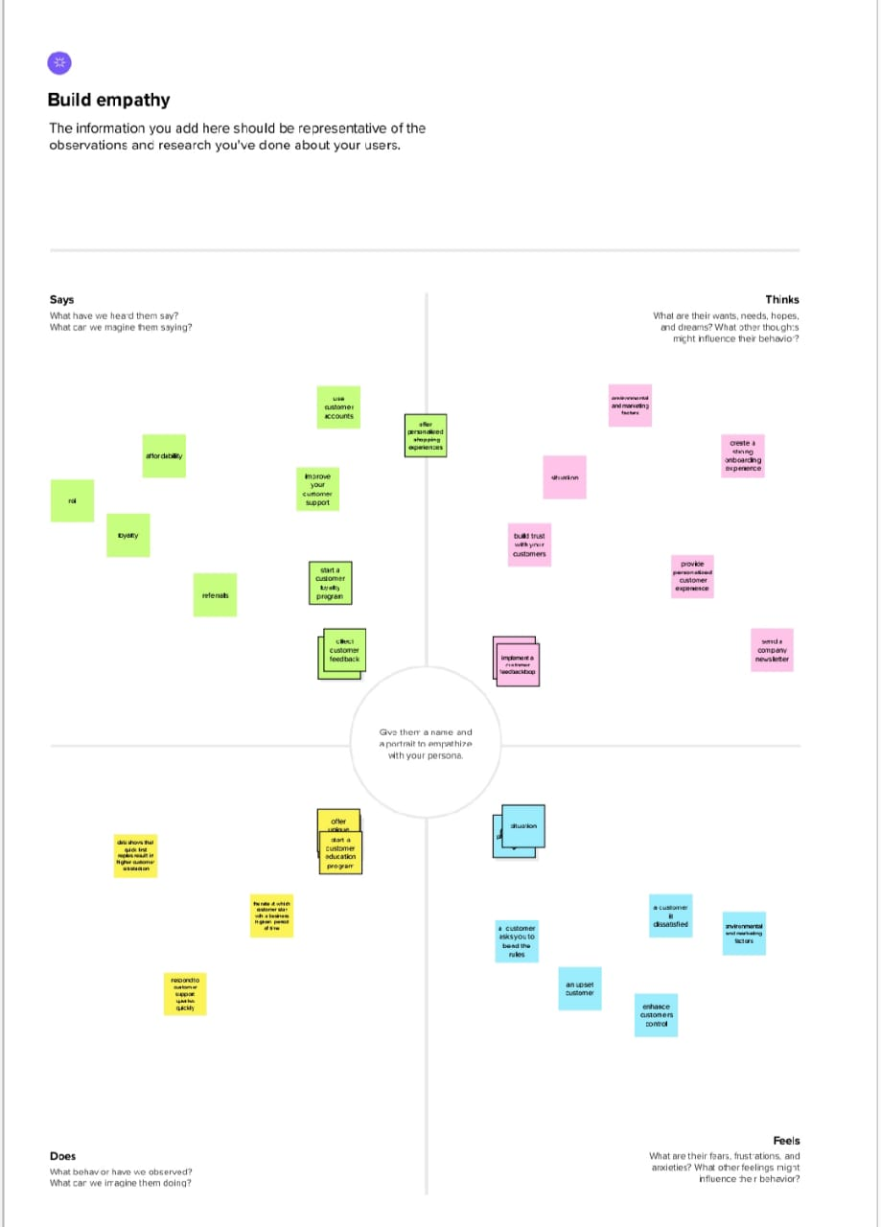

Result:


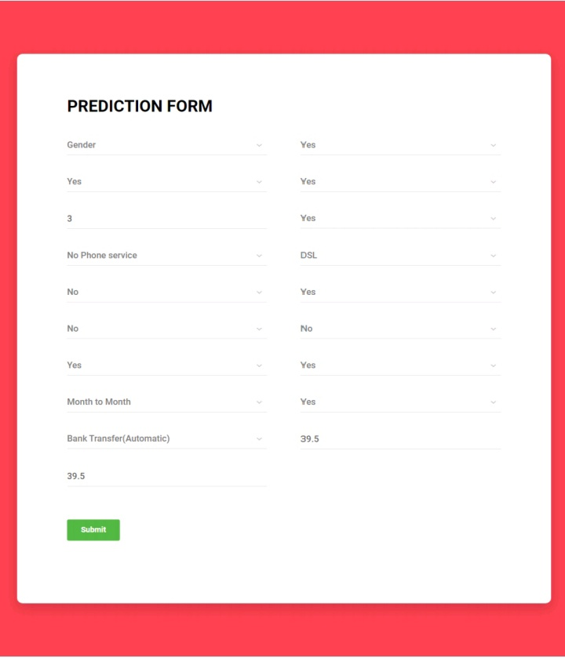

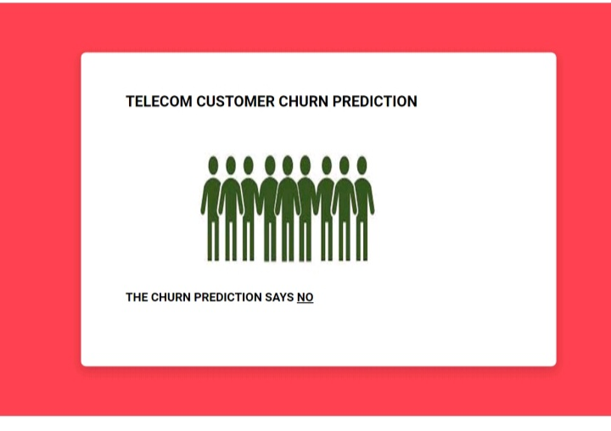
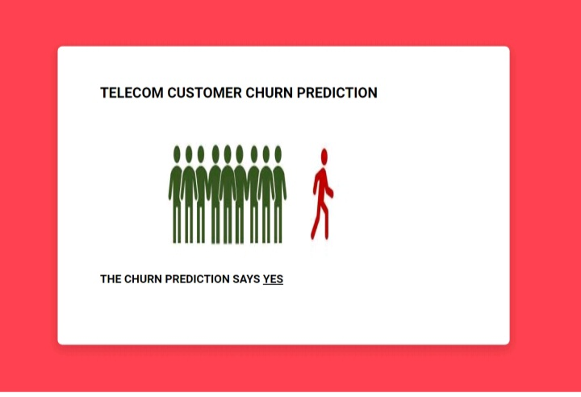
Advantages:

- Retention is more cost-effective than acquisition. According to a report, it costs five times as much to bring in new customers compared to selling to existing ones.
- It’s know fact that people get strongly influenced by referral from family and friends. Hence loyal customers are the best source of referrals and new business.
- Customers boarded through a referral or loyalty membership tend to have a much shorter sales cycle .
- Customer retention also helps businesses improve CLV (Customer Lifetime Value) and reduce churn.

Disadvantages:
- There are some disadvantages to consider when analysing the churn rate.
- While it may be useful to know the number of customers that have left the business, the churn rate can’t provide details of who those customers are for examples, newly subscribed customers may be more likely to churn than more established clients.
- Investing in customer retention both in terms of price and time can prove to be steep.
- Business trying to achieve an efficient customer retention rate may not focus on the needs of new customers.
- There may be chances of new customers being overlooked by brand in a hoard to satisfy their existing customers.
- If you choose the wrong loyalty partner, you may end up investing heavily in the partnership and loyalty card processing costs but not reap the benefits.

Application:
- Churn prediction is predicting which customers are to high risk of leaving your company or cancelling a subscription to a service, based on their behaviour with your product.
Conclusion:

- In this post, we have walked through a complete end-to-end machine learning project using the Telco customer churn data set. We started by cleaning the data and analysing it with visualization. then, to the able to build a machine learning model, we transformed the categorical data into numerical variables (feature engineering)

- After transforming the data, we tried 6 different machine learning algorithms using default parameters. finally, we tuned the hyper parameters of the gradient boosting classifier (best performance model) for model optimization, obtaining an accuracy of nearly 80%(close to 6% higher than the baseline)

- It is important to stress that the exact steps of a machine learning task Vary by the project.

- Although in the article we followed a linear processes, where previous steps are often revisited as we learn more about the problem we tried to solve.

Future scope:
- Predicting Customer Churn, Churn prediction means detecting which customers are likely to leave a service or to cancel a subscription to a service.
- It is a critical prediction for many businesses because acquiring new clients often costs more than retaining existing ones.
- It identifies target customers, ascertains the needs of these customers, and then specifies how the product satisfies theses needs.

